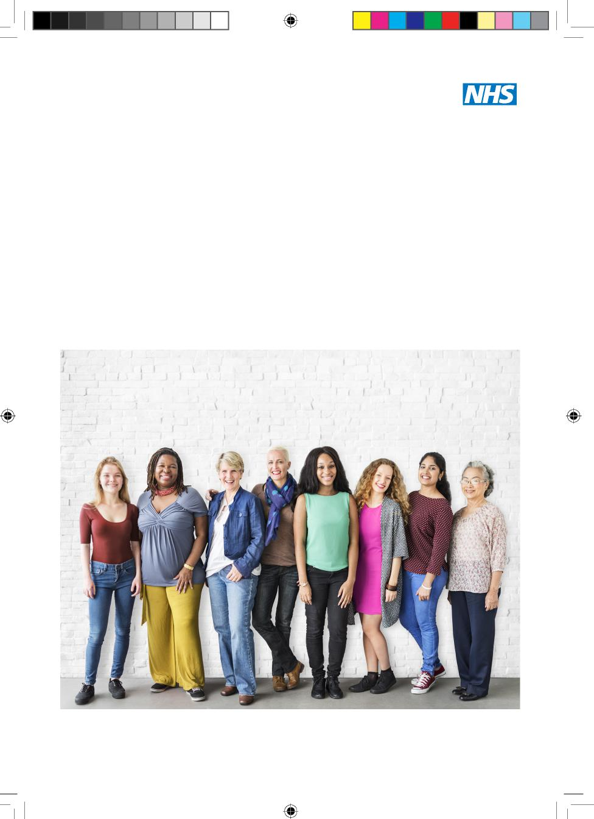
NHS cervical screening Helping you decide
Public Health England (PHE) created this leaflet on behalf of the NHS
Cervical helping you decide HPV May2019.indd 1 28/05/2019 08:27:08
NHS cervical screening: helping you decide

It is your choice whether to have a cervical screening test or not. This leaflet aims to help you decide. Cervical screening used to be called a ‘smear test’.
Why we offer cervical screening
NHS cervical screening helps prevent cervical cancer. It saves thousands of lives from cervical cancer each year in the UK.^{1.2} In England cervical screening currently prevents 70% of cervical cancer deaths. If everyone attended screening regularly, 83% could be prevented.³
Who we invite
We offer cervical screening every 3 years from age 25 to 49 and every 5 years from age 50 to 64. This is because most cervical cancers develop between these ages. First invitations arrive a few months before people turn 25. You can book your appointment as soon as you get your invitation. We invite some people more often due to a previous screening result (see page 9).
You should consider having screening regardless of your sexual orientation, sexual history, or whether you have had the HPV vaccination.
If you are a transgender (trans) man registered with your GP as female, we will send you invitations for cervical screening. If you are registered as male you won’t receive invitations, but your GP or practice nurse can arrange an appointment for you if you have a cervix. If you are a trans woman you don’t need cervical screening.
2
Cervical helping you decide HPV May2019.indd 2 28/05/2019 08:27:08
NHS cervical screening: helping you decide

Cervical cancer
Cervical cancer happens when cells in the cervix grow in an uncontrolled way and build up to form a lump (also called a tumour). As the tumour grows, cells can eventually spread to other parts of the body and become life-threatening.
Your cervix is the lowest part of your uterus (or womb), and it is found at the top of your vagina.

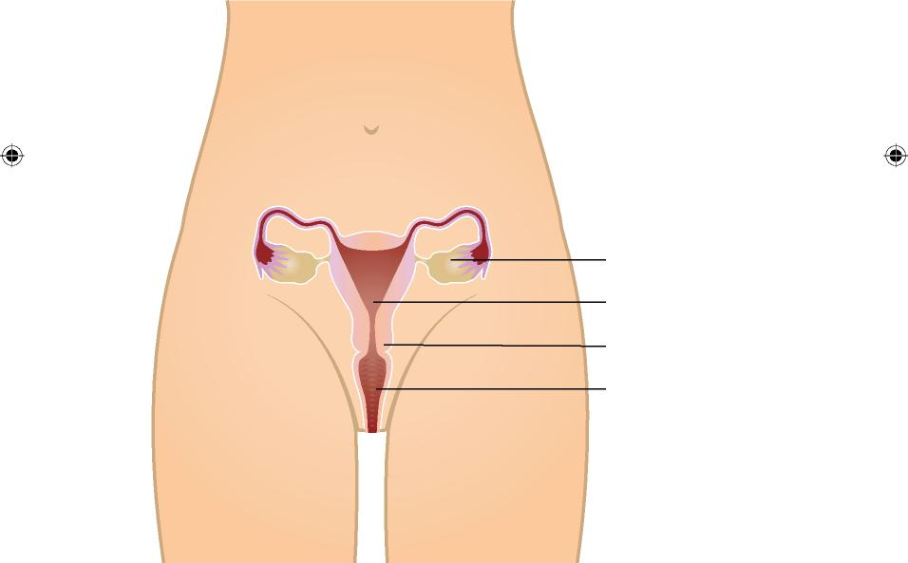
Ovary
Uterus (womb)
Cervix
Vagina

Diagram showing the female reproductive system. The cervix is at the top of the vagina.
3
Cervical helping you decide HPV May2019.indd 3 28/05/2019 08:27:08

NHS cervical screening: helping you decide

HPV and cervical cancer
Nearly all cervical cancers are caused by a virus called human papillomavirus (HPV).
HPV is very common. Most people will get the virus at some point in their life. It is spread through close skin to skin contact during any type of sexual activity with a man or woman. HPV can stay in the body for many years. It can stay at very low or undetectable levels and not cause any problems. This means an HPV infection may have come from a partner a long time ago.
There are many different types of HPV, but only some high-risk types can lead to cancer. The types of HPV that cause cervical cancer do not cause any symptoms. In most cases, your immune system can get rid of the virus without you ever knowing you had it. But sometimes, HPV can cause cells in your cervix to become abnormal.
Your body can usually get rid of the abnormal cells and your cervix returns to normal. But sometimes this doesn’t happen, and the abnormal cells can go on to develop into cancer.
What affects your chances of getting cervical cancer
Having cervical screening lowers your chances of getting cervical cancer. Screening finds abnormal cells so they can be removed before they become cancer.
HPV is found on the skin around the whole genital area and can be spread through any type of sexual activity. This means that
condoms or dental dams can help prevent infection, but they don’t
4
Cervical helping you decide HPV May2019.indd 4 28/05/2019 08:27:09
NHS cervical screening: helping you decide

provide total protection from HPV.
Smoking increases the risk of cervical cancer because it makes it
harder for your body to get rid of HPV infections. Information about stopping smoking is available at www.nhs.uk/smokefree
The HPV vaccination protects against the types of high-risk
HPV that cause most cervical cancers. If you have had the HPV vaccination you will still need to consider having cervical screening when you are invited. This is to check for other high-risk HPV types that can lead to cervical cancer.
Having a family history of cervical cancer does not affect your chances of developing cervical cancer.
How cervical screening works
Cervical screening is not a test for cancer. It looks for abnormal cells in the cervix. Abnormal cells can develop into cancer if left untreated.
The test involves using a soft brush to take a small sample of cells from the surface of your cervix. The sample is put into a small plastic container and sent to a laboratory. It is tested for the types of HPV that can cause cervical cancer. If you have a negative result for the most common types of HPV that cause cervical cancer, your risk of cervical cancer is very low and there is no need to check for abnormal cells even if you have had these in the past.
If you have a positive result for HPV we will check the sample for abnormal cells. Abnormal cells are not cancer, but they could develop into cancer if left untreated.
5
Cervical helping you decide HPV May2019.indd 5 28/05/2019 08:27:09
NHS cervical screening: helping you decide

As a next step we may offer you another examination (called a colposcopy) to look at your cervix more closely. If we find abnormal cells during colposcopy we may suggest you have the cells removed. This is how screening can prevent cervical cancer.

No screening test is 100% effective. In cervical screening this is because:
- an HPV infection or abnormal cells can sometimes be missed (a ‘false negative’ result)
- abnormal cells can develop and turn into cancer in between screening tests
- there is a small chance that a result says abnormal cells are
found when the cervix is normal (a ‘false positive’ result)
If screening does not find abnormal cells this does not guarantee that you do not have them, or that they will never develop in the future.

Having cervical screening
Before your appointment
Cervical screening is usually carried out by a female nurse or doctor. If you want to make sure a woman carries out your test, you can ask for this when you make your appointment.
Your appointment should be on a day when you are not having a
period. If you don’t have periods, you can be screened at any time.
Please don’t use any vaginal medications, lubricants or creams in the 2 days before you have your test because they can affect the results.
6
Cervical helping you decide HPV May2019.indd 6 28/05/2019 08:27:09

NHS cervical screening: helping you decide

Please talk to your nurse or doctor if you:
- are pregnant
- have had a hysterectomy
- think it would be difficult for you to have the test
You can speak to your nurse or doctor if you are nervous about screening. They can talk through any questions or concerns you have. If you decide to go ahead with screening, they can make arrangements to help you feel more comfortable.
At your appointment
The actual test only takes 1 to 2 minutes. The whole appointment
usually takes about 10 minutes.
The nurse or doctor will ask you to undress from your waist down (or just remove your underwear if you are wearing a loose skirt) and lie on a bed with your knees bent and apart. You will have a paper sheet or towel to cover your stomach and hips.
They will put a device called a speculum into your vagina and open it gently. This allows them to see your cervix. The speculum is usually made of plastic and a new one is used for each screening test. The nurse or doctor then uses a small soft brush to take a sample of cells from the surface of your cervix. You might feel some discomfort, but this should go away quickly. If it feels painful, tell the nurse or doctor and they will try to make it more comfortable for you.
You are in control of your screening appointment, and you can ask to stop at any time.
7
Cervical helping you decide HPV May2019.indd 7 28/05/2019 08:27:09
NHS cervical screening: helping you decide

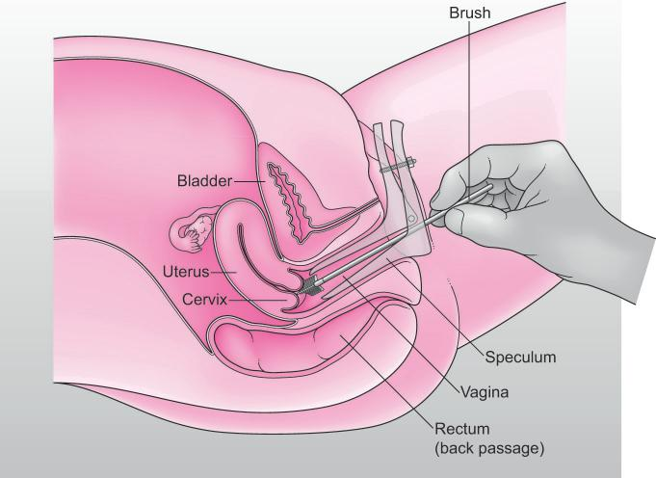
© Jo’s Cervical Cancer Trust

Diagram showing how a cervical screening sample is taken using a speculum and a small soft brush.
Cervical screening results
The nurse or doctor will tell you when you can expect your results letter. There are 4 possible results.
1. HPV negative
An HPV negative result means we will not do any further tests. This result means it is highly unlikely that you will have any abnormal cervical cells. Even if you did, it would be extremely unlikely that they would cause a problem. We will simply call you back for screening again in 3 or 5 years’ time (depending on your age).
8
Cervical helping you decide HPV May2019.indd 8 28/05/2019 08:27:16

NHS cervical screening: helping you decide

- HPV positive: no abnormal cells
If your sample is HPV positive we also test it for abnormal cervical cells. If none are found, your result will say you have HPV, but no abnormal cells. We will ask you to come for screening again sooner than usual (your result letter will explain when). This is so we can check if your immune system has got rid of the HPV (this happens in most cases).
- HPV positive: abnormal cells found
There are several ‘grades’ of abnormal cells as some are more serious than others. Your result letter will explain what your results mean. If you have HPV and any grade of abnormal cervical cells we will refer you for colposcopy (see page 11). We will send you our information leaflet ‘NHS cervical screening – having a colposcopy’.
- Inadequate result
Occasionally a sample may be called ‘inadequate’. This may be due to a technical problem, for example if the laboratory cannot get an HPV test result from your sample or cannot see if abnormal cells are present or not. If you have an inadequate test, we will ask you to have cervical screening again in 3 months’ time. We wait so that there are enough cells again to get a sample from.

9
Cervical helping you decide HPV May2019.indd 9 28/05/2019 08:27:16

NHS cervical screening: helping you decide

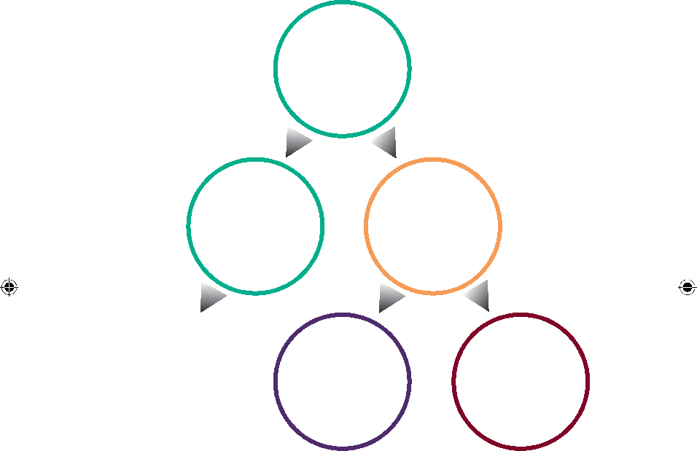
100
women have
cervical
screening
87
have an
HPV negative
result...
13
have an
HPV positive
result
... and are invited for screening again in 3 or
5 years
9
are invited
for screening
again in 12
months
4
are referred
to have
colposcopy

Diagram showing the results for every 100 people who have cervical screening
10
Cervical helping you decide HPV May2019.indd 10 28/05/2019 08:27:19

NHS cervical screening: helping you decide

What happens to samples after screening
Depending on your screening result your screening sample may be kept by the laboratory for at least 10 years. Your result will be kept on a national secure computer system so that the NHS can compare your latest result with ones you have had before.
Find out how Public Health England and the NHS use and protect your screening information at: www.gov.uk/phe/screening-data
Colposcopy
Colposcopy is usually carried out in a hospital clinic. A specialist will take a close look at your cervix using a magnifying lens with a light (a ‘colposcope’). They may take a small tissue sample (a biopsy) to check any areas of your cervix which look unusual. If the abnormal cells are serious, you may need treatment to remove them. This helps prevent cervical cancer.
You can read more about colposcopy in our leaflet at: www.gov.uk/government/publications/cervical-screening-colposcopy

11
Cervical helping you decide HPV May2019.indd 11 28/05/2019 08:27:19

NHS cervical screening: helping you decide

Possible benefits and risks of cervical screening
It is your choice whether to have cervical screening. To help you decide, we’ve included information on the possible benefits and risks.
Possible benefits
Cervical screening helps prevent cervical cancer. Cervical screening saves thousands of lives from cervical cancer every year in the UK.^{1,2}
Possible risks
The main risks of cervical screening come from removing abnormal cells during a colposcopy and not from the screening test itself. Removing abnormal cells can sometimes cause bleeding or an infection, and it can also affect future pregnancies. Women who get pregnant after having abnormal cells removed are not at increased risk of having their baby early if they have standard treatment. If more cervical tissue needs to be removed, women are slightly more likely to have their baby 1 to 2 months early. This may affect around 16% of women (16 in 100) who have this more extensive treatment and then have a baby.⁴
Not everyone who has abnormal cells removed would have gone on to develop cervical cancer. We offer treatment to everyone with serious abnormal cells because it is not possible to tell who will and who will not develop cervical cancer.
12
Cervical helping you decide HPV May2019.indd 12 28/05/2019 08:27:19
NHS cervical screening: helping you decide

Symptoms of cervical cancer
Cancer can start to develop between your regular screening tests. It is important to look out for anything that is unusual for you, especially:
- bleeding between your periods, during or after sex, or after the menopause
- changes to vaginal discharge

Screening is not a test for investigating symptoms.
If you have any of these changes, don’t wait for your next cervical screening appointment. See your GP as soon as possible. Your GP can examine you and refer you to a gynaecology clinic if necessary.

Usually these symptoms will not mean you have cancer. But if you are found to have cancer, getting it diagnosed and treated early can mean you are more likely to survive.

13
Cervical helping you decide HPV May2019.indd 13 28/05/2019 08:27:19

NHS cervical screening: helping you decide

More information and support
If you have any questions about cervical screening, you can talk to your GP, practice nurse or visit a local contraceptive/sexual health clinic.
There is more information about cervical screening at: www.nhs.uk/cervical
For more information about colposcopy, see our leaflet at: www.gov.uk/government/publications/cervical-screening-colposcopy
To opt out of screening, see:
www.gov.uk/phe/screening-opt-out

14
Cervical helping you decide HPV May2019.indd 14 28/05/2019 08:27:19

NHS cervical screening: helping you decide

References
- Peto, R and others (2004). The cervical cancer epidemic that screening has prevented in the UK. Lancet 35, 249–256.
- Castanon, A and others (2017). By how much could screening by primary human papillomavirus testing reduce cervical cancer incidence in England? Journal of Medical Screening vol. 24, (2) 110-112.
- Public Health England. Health Matters: making cervical screening more accessible (2017). Accessed 14/03/2019. www.gov.uk/government/publications/health-matters-making-cervical-screening-more-accessible/health-matters-making-cervical-screening-more-accessible--2
- Sasieni, P and others (2015). Risk of preterm birth following surgical treatment for cervical disease: executive summary of a recent symposium. British Journal of Obstetrics and Gynaecology 123: 1429-1429.

15
Cervical helping you decide HPV May2019.indd 15 28/05/2019 08:27:19

An HTML version of this leaflet is available. You can view and download it in large print, and use a screen reader for an audio version. Visit: www.gov.uk/phe/cervical-screening-leaflet

We can provide a braille version. Email: phe.screeninghelpdesk@nhs.net

Image credit(s)
cover image: Shutterstock/Rawpixel.com
Page 8: Jo’s Cervical Cancer Trust
You may re-use this information (excluding logos) free of charge in any format or medium, under the terms of the Open Government Licence v3.0. Where we have identified any third party copyright information you will need to obtain permission from the copyright holders concerned.
PHE publications gateway number: GW-339
First published: June 2019 This version: June 2019 Review due: June 2022 | Leaflet reference: CSP14  PN2464547  © Crown copyright 2019

 | Public Health England supports the UN Sustainable Development Goals
 | 

Cervical helping you decide HPV May2019.indd 16 28/05/2019 08:27:21

